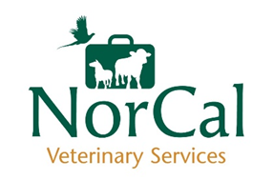

NorCal Vets Student Placement Application Form

Name:
DOB:
Email address:
Phone number:
Address:
University attending:
Current year of study:
Specific areas of interest in farm veterinary:
Previous Farm Work Experience/ Farm EMS:
Previously attended placement at NorCal?
Reasons for choosing NorCal Vets for a placement:
Dates available for placement:

